

Faculty of Computer Science and Mathematics

Universiti Malaysia Terengganu

LAB REPORT

CSE3023 Web-Based Application Development

Name | Wai Pei Yuen
Matric No. | S74991
Semester | 2025/26-2
Lab Report | 6
Demonstrator | Ts. Dr. Wan Nural Jawahir Hj Wan Yussof

Exercise:
Source Code:
insertUser.html
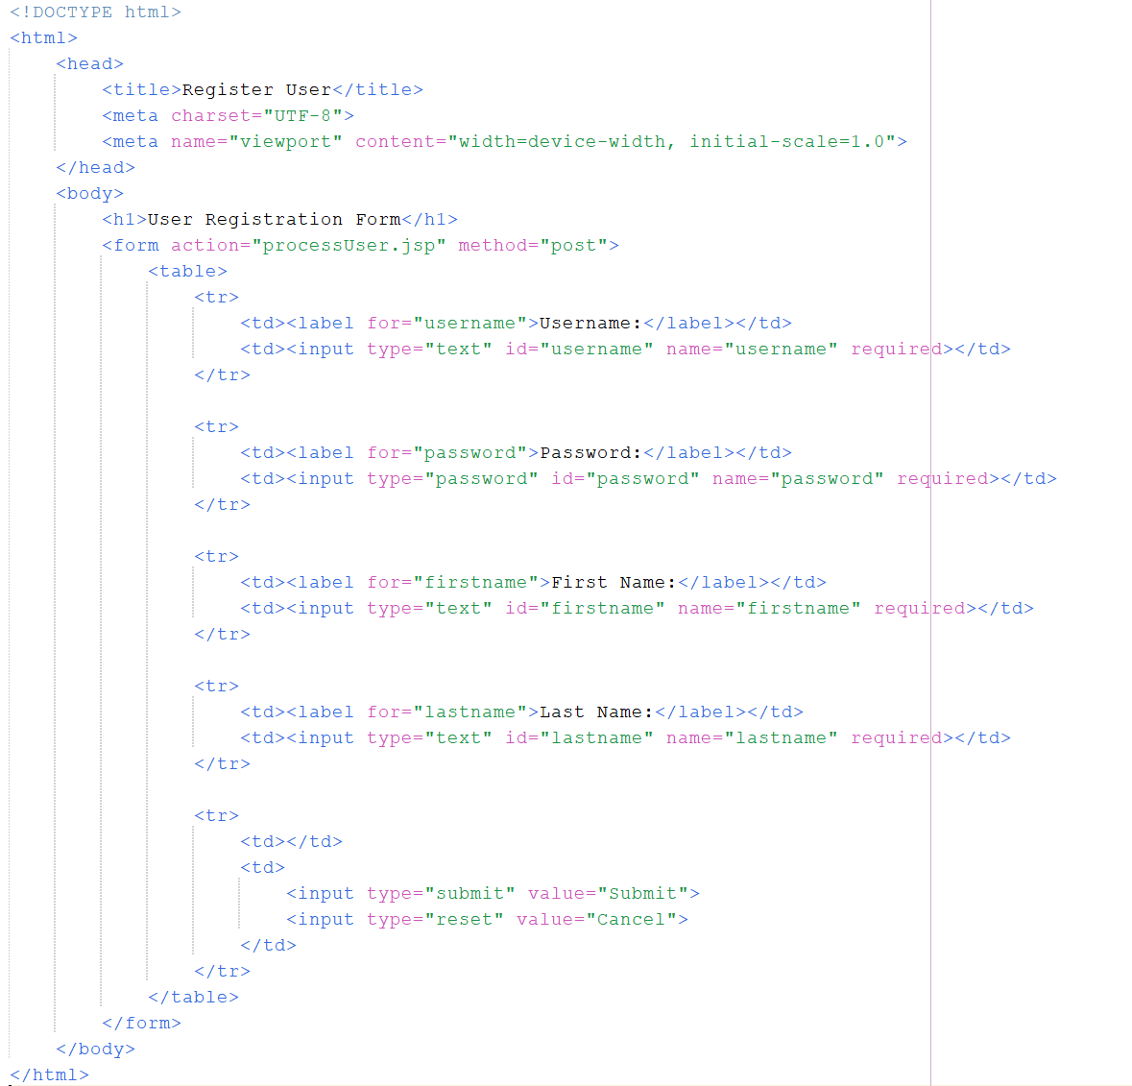

processUser.jsp
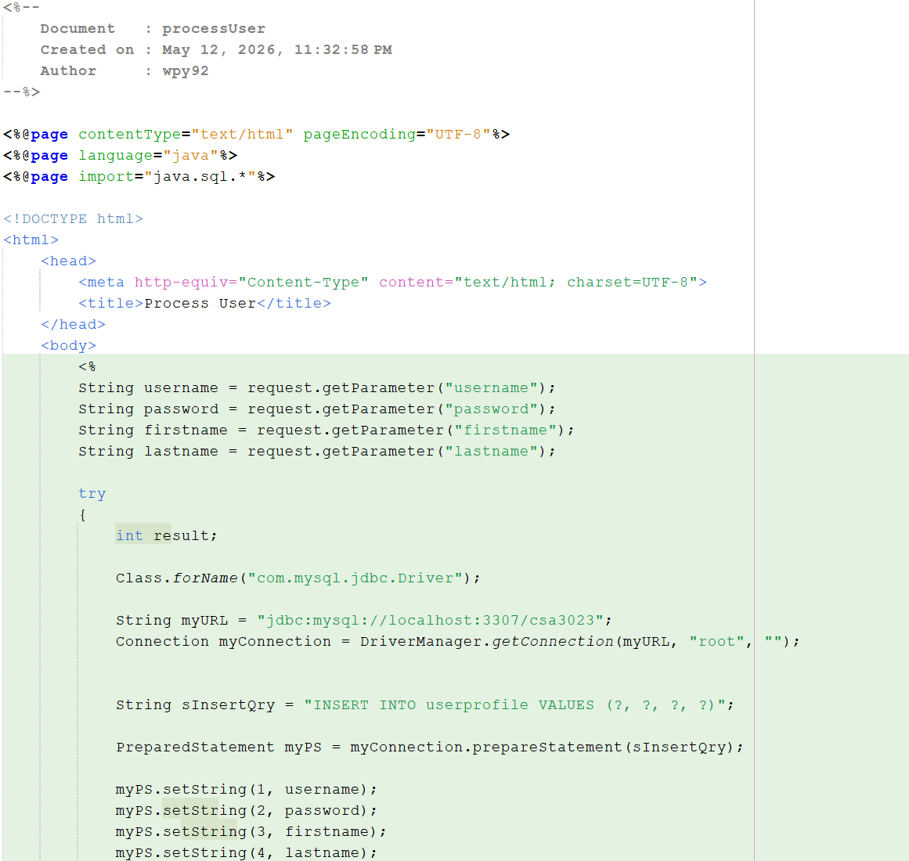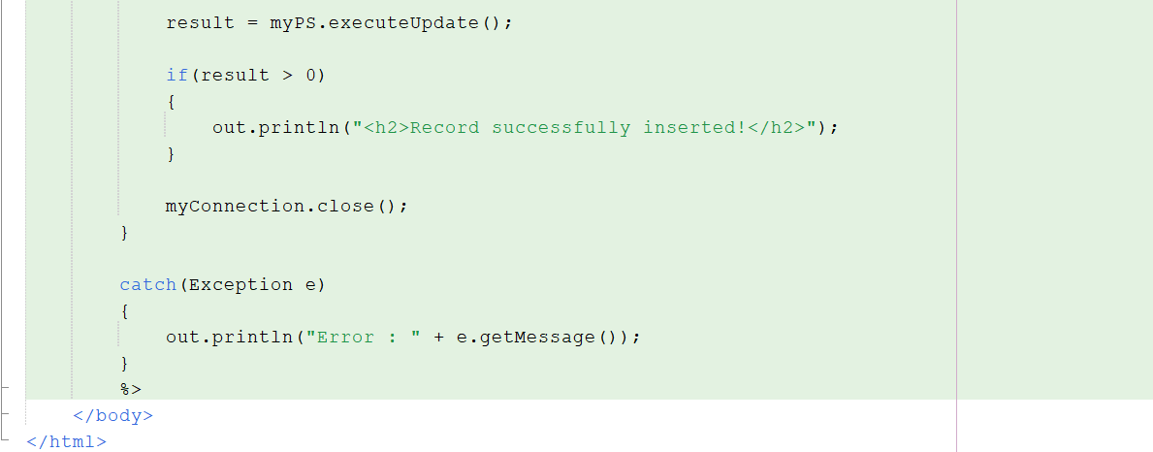

login.jsp
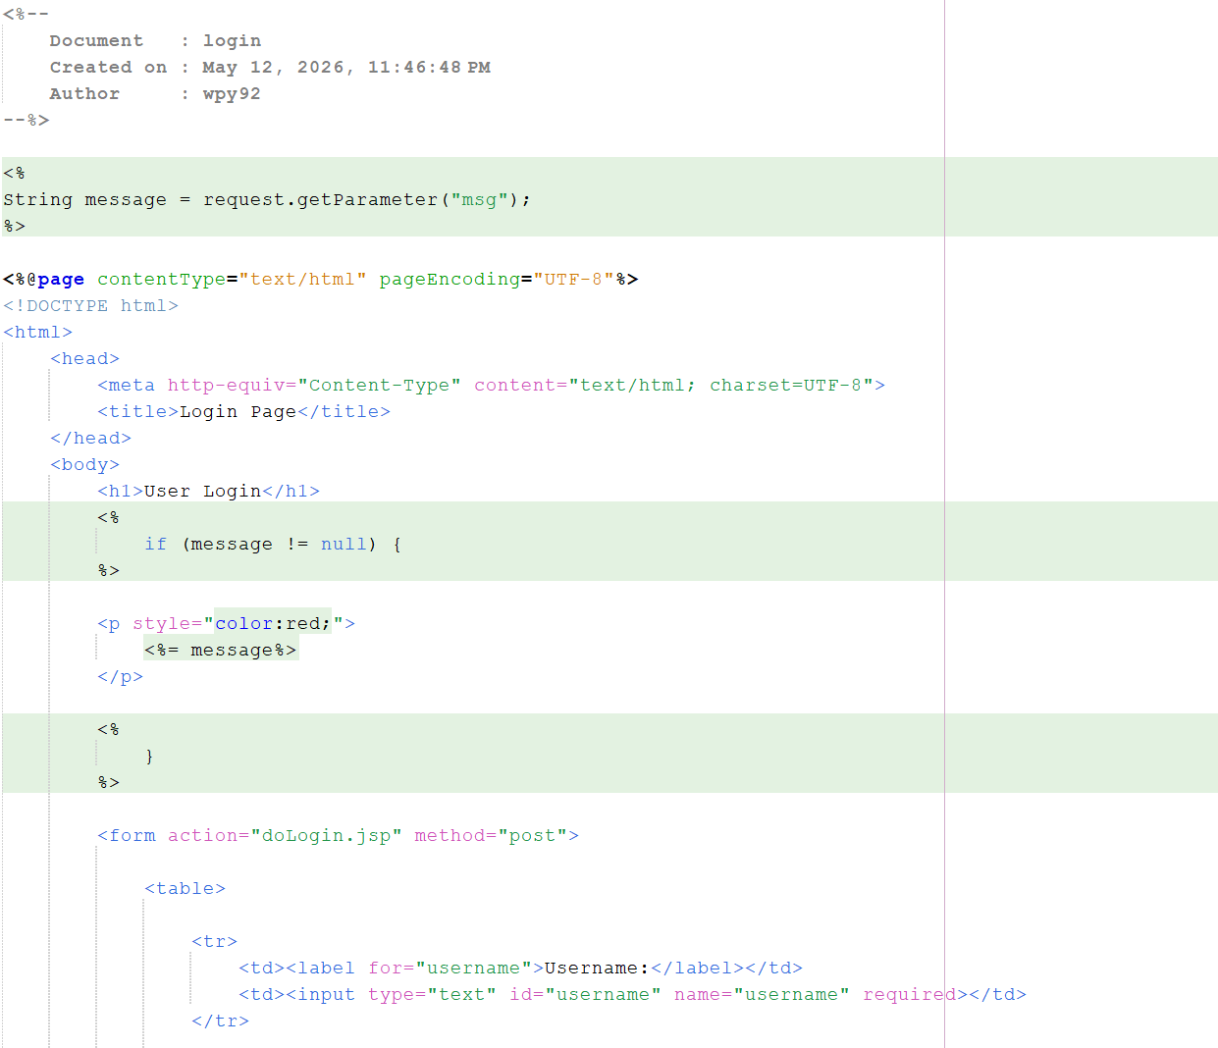

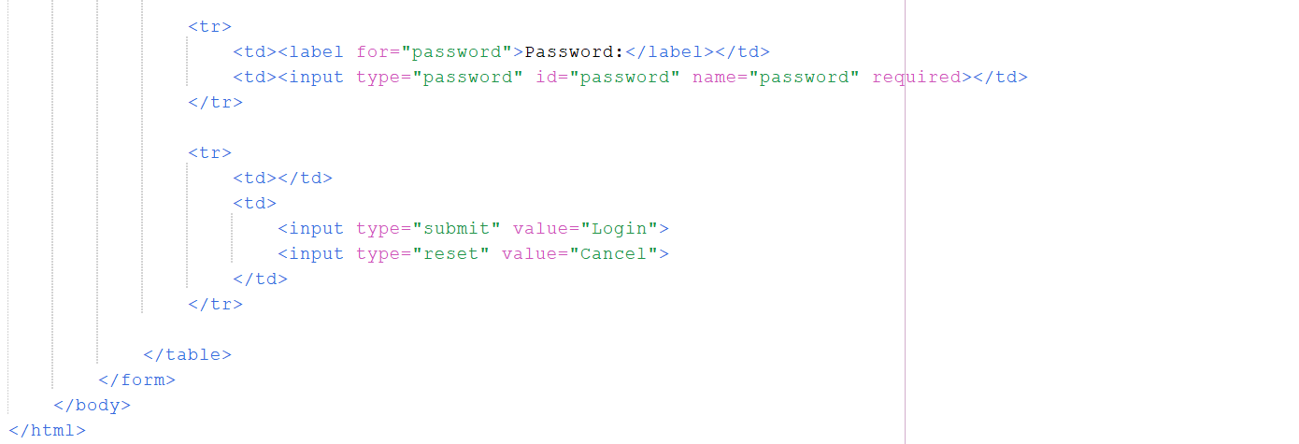
doLogin.jsp
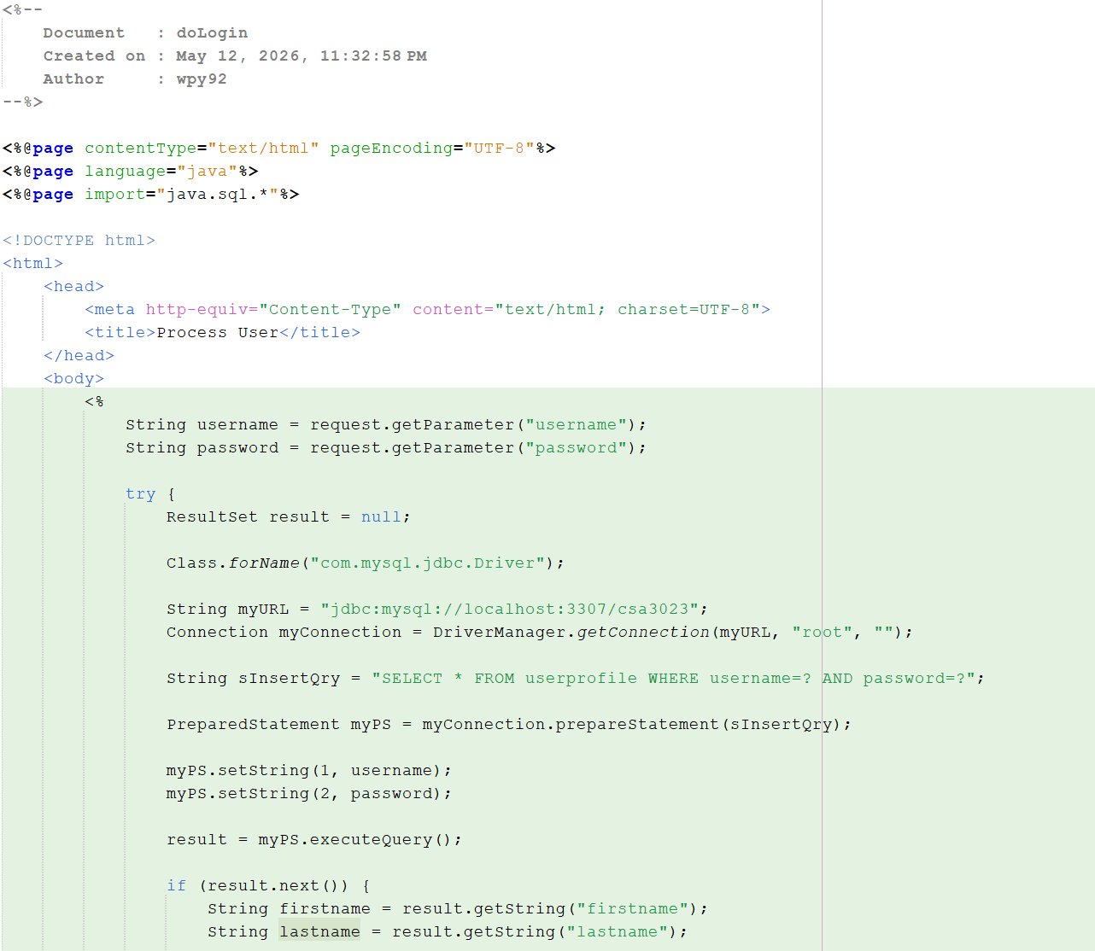
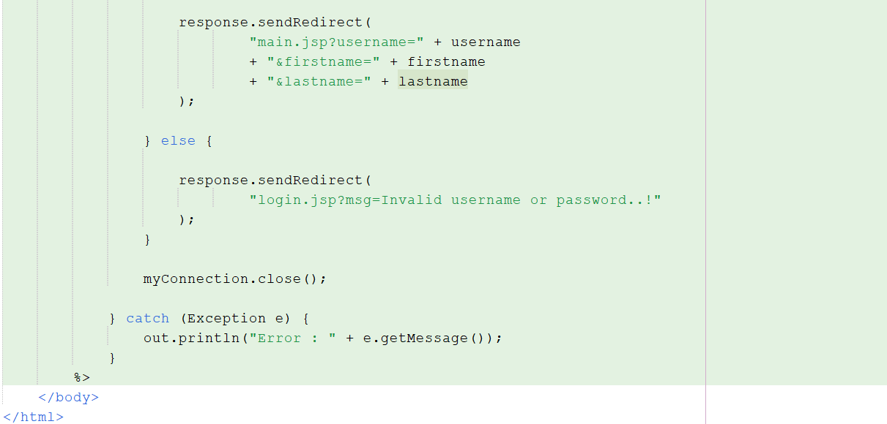

main.jsp
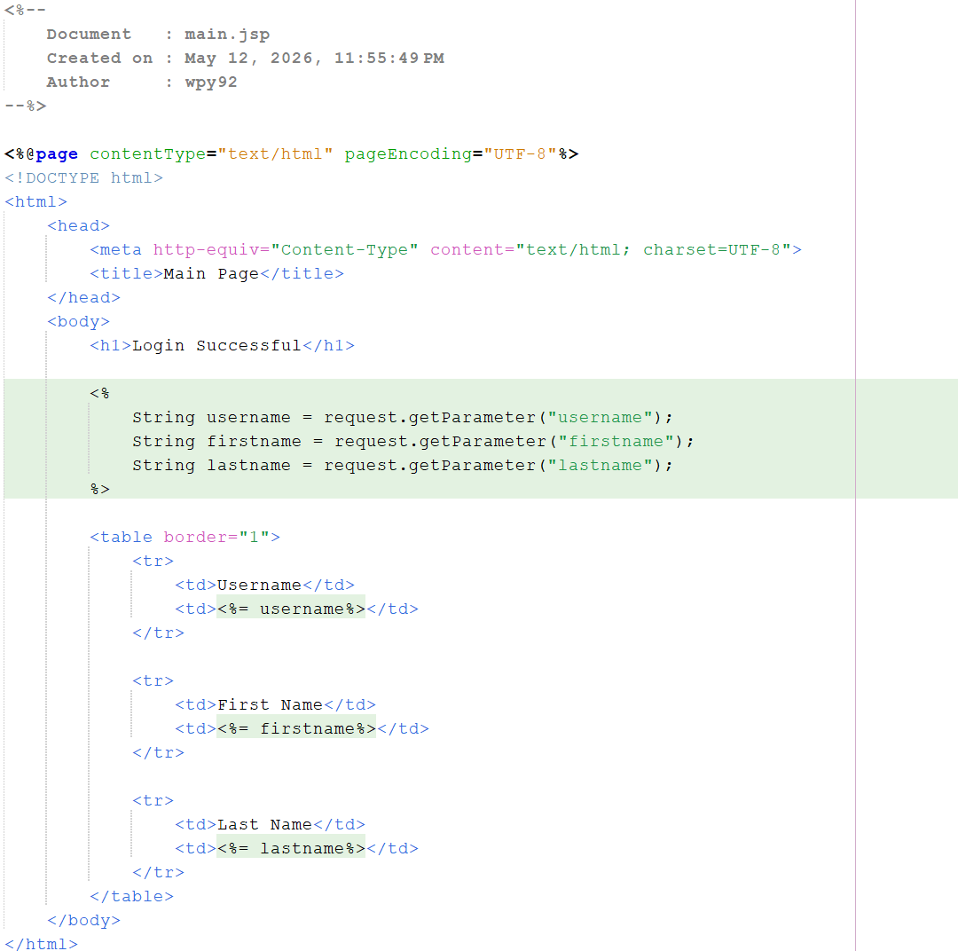

Output:
insertUser.html
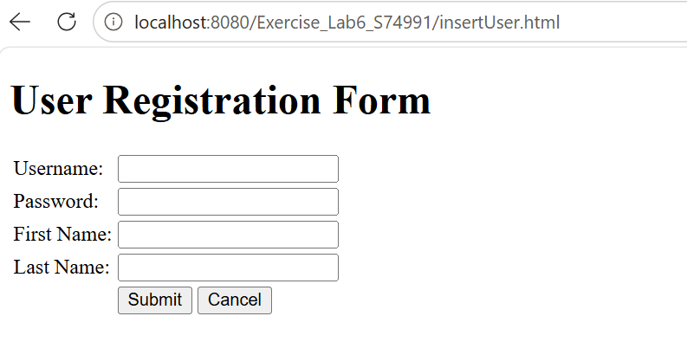
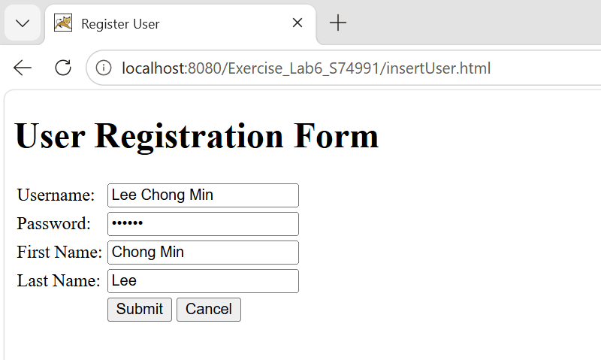

Result
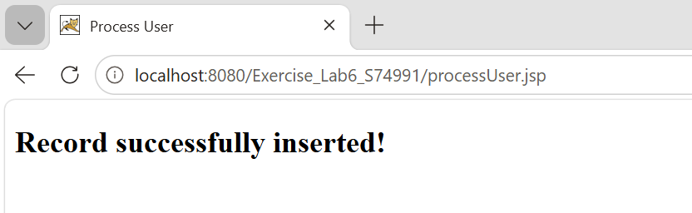
login.jsp
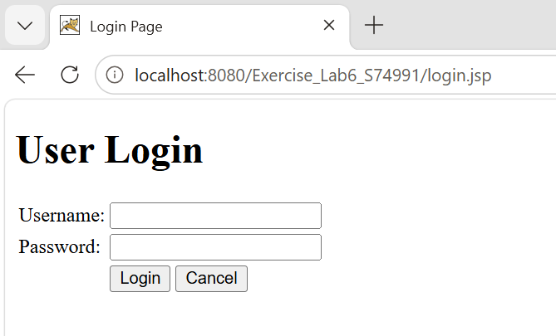

If the username and password correct
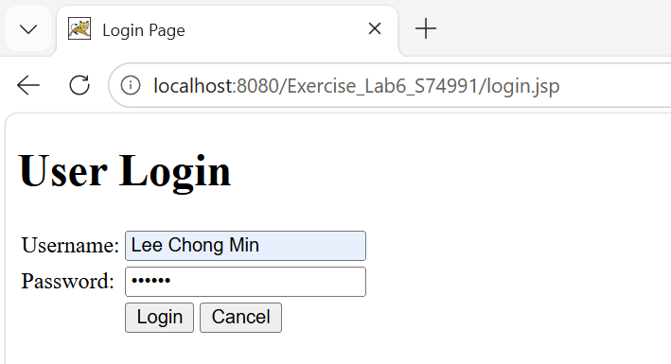

Result (direct to main.jsp)
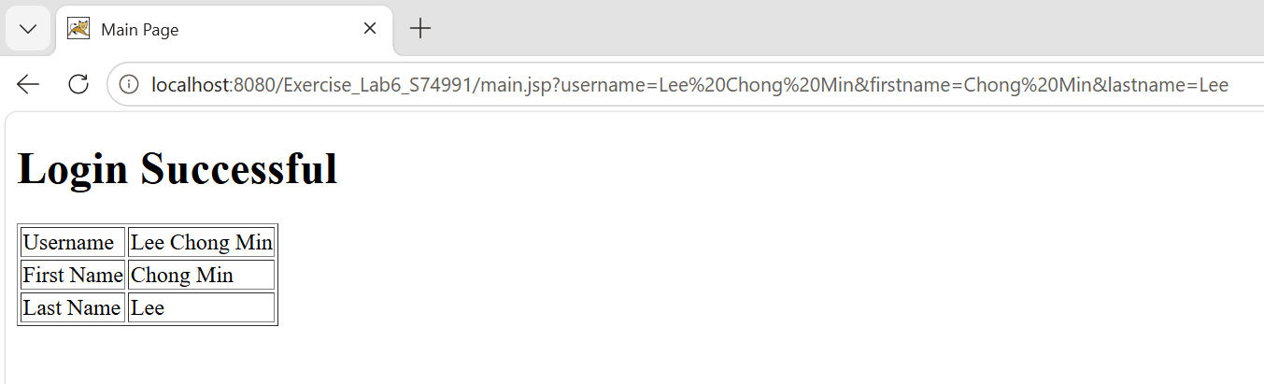

If the username and password incorrect
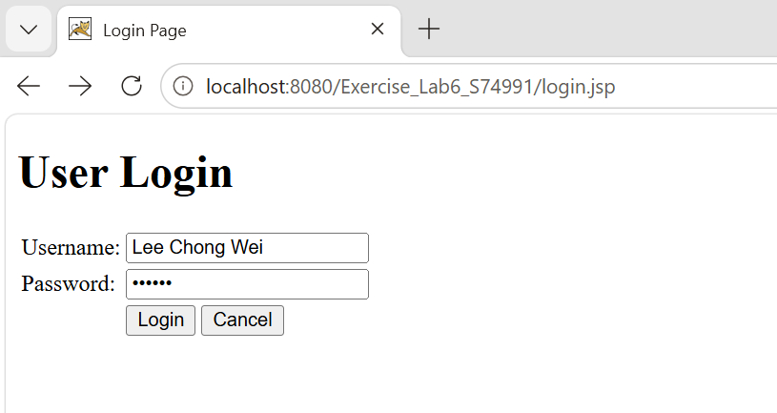

Result (redirect to login.jsp)
